Guide to the Disability Access Fund (DAF) |  |  | Easy Read | 
 |  | Children aged 9 months to 2-year-olds who are in receipt of 15 hours entitlement for children of working parents and disadvantaged 2-year-olds and are in receipt of Disability Living Allowance (DLA) are eligible.  Three and four-years-olds who are in receipt of the universal 15 hours entitlement and are in receipt of Disability Living Allowance (DLA) are eligible.  https://www.gov.uk/disability-living-allowance-children
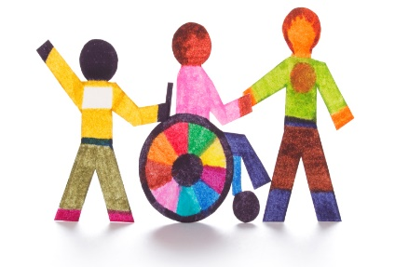 |  | Early Years providers can apply for DAF to support children with disabilities or Special Educational Needs.  http://www.kelsi.org.uk/early-years/equality-and-inclusion/disability-access-fund-daf
 |  | DAF aids access to Early Years places by supporting childcare providers in making reasonable adjustments to their provision.
 |  | DAF is paid to one childcare provider nominated by the parent. If the funding is agreed, they will receive an annual one-off payment of £910.00 per eligible child.
 |  | To apply, the childcare provider requires parent’s written consent and a copy of the child’s DLA letter of confirmation. The childcare provider must keep a copy of the form and DLA confirmation as proof of eligibility.
 |  | DAF is not transferable to another childcare provider if the child moves to another setting. The new childcare provider is not eligible to receive DAF for the child within the same financial year, however a proportion of DAF can be transferred to the new setting if both providers are agreeable.

