
Summer Holiday Support - 2026

Dear Parents/Carers,

As we approach the summer holidays, I wanted to share some information with you on services that are available locally to support families. Please find attached a list of organisations and helplines offering support. I have also attached some activity ideas that I hope will be helpful.

As the school FLO (Family Liaison Officer), I am here to help support you, your child and family. If you have any concerns or need to talk, please don’t hesitate to reach out. You can contact me during school hours by calling 01797 344 335 and selecting option 2. Alternatively, you can email me at flo@brenzett.kent.sch.uk. I am also available during the school day for drop-in sessions should you wish to come in for a face-to-face discussion and a hot chocolate!

Wishing you a safe and enjoyable summer break and I look forward to seeing you all on our return to school in September.

Kindest Regards,
Rhiannon Gilbert (FLO)

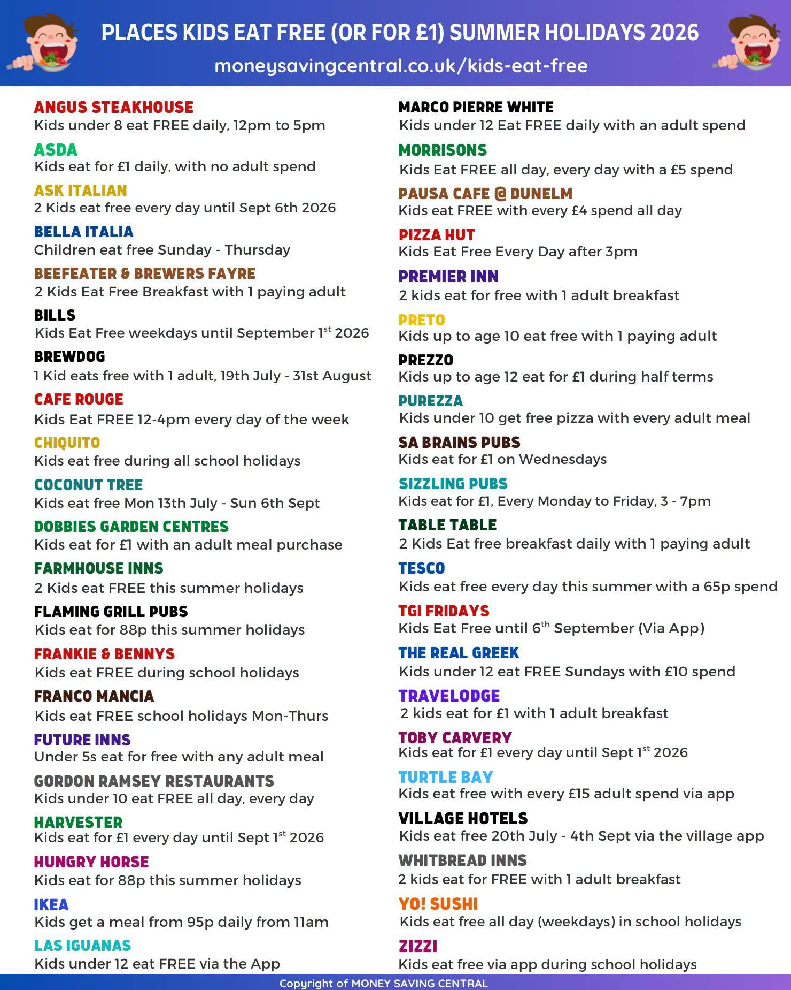
Food Bank Services:

Folkestone/Hythe/Romney Marsh:
Step 1 – Referral Agency
In order to provide the most appropriate help for the circumstances of your situation, we work with local agencies. If they feel you are struggling to put food on the table, they will issue you with a foodbank voucher.
The local agency can also provide long-term support if needed to help address some of the issues behind the reasons for your crisis. Citizens Advice, schools, and health professionals are just some of those who can refer people to our Foodbank.
If you are in crisis but are not currently working with a support agency that can refer you, please contact the ‘Help Through Hardship’ line on 08082 082138 to be assessed for a Food Voucher.
Step 2 – Food Voucher
When you contact a referral agency they will take some details from you to complete the voucher. This will help them to identify the cause of your crisis and offer practical guidance. It also means we are able to prepare suitable emergency food for the right number of people. Please let the referrer know if you have any allergies or special dietary requirements and they can note this on the voucher.
All our vouchers are now digital so, once issued, they are automatically sent to the Foodbank. Please note: you will not receive a physical voucher.
Step 3 – Food Parcel
We run Foodbanks in 6 locations around the district, Lydd, New Romney, Folkestone, Hawkinge, and Cheriton, places and times can be seen below.
Once we receive your voucher, we will make up your food parcel, accommodating your dietary requirements wherever possible, and this will be available for collection at the Foodbank Centre specified by the voucher issuer.
- 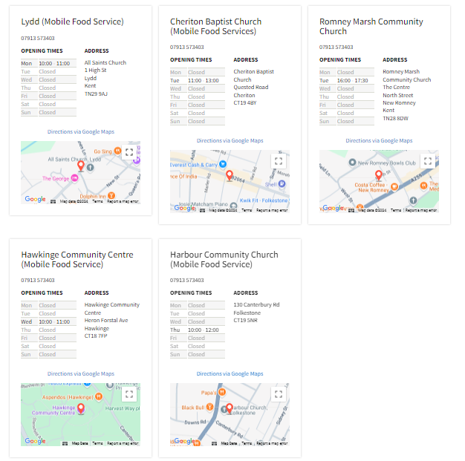

Ashford:
Location of Ashford Food banks, Opening Times and Contact Details
Food bank | Address | Contact | Normal Opening Times
Pneuma Church | The Warehouse, Ashford Works, Cobbs Wood Industrial Estate, Brunswick Road, Ashford, TN23 1EH  Directions to Pneuma Church | T: 01233 331919  Visit Pneuma Church website  Email Pneuma Church | Monday-Friday 10am-12pm
Repton Community Trust | Repton Connect Community Centre, Repton Avenue, Ashford, TN23 3RX  Directions to Repton Connect Community Centre | T: 01233 808023  Visit Repton Connect Community Centre website  Email Repton Connect Community Centre | The Community Shop will  be open Mondays 1pm-2pm and Tuesday-Friday 10am-11am.  Starting at a donation of £1.50 for every £5 worth of items, you’ll be able to get a maximum of £20 worth of shopping for just £6!  We will work just like a normal shop, you’ll be able to pick up a basket, make your way round the shop selecting the items you need, then once you’ve found all you need, bring the basket to us and we’ll pack your items for you.  Although the People’s Pantry is moving to a Community Shop, we are still here for emergency food parcels.
ICM Ashford Pentecostal Church and Boxes of Hope | ICM Office, First Floor, 65 High Street, Ashford TN24 8SG  Directions to ICM Ashford Pentecostal Church | T: 01233 340194  Visit ICM Pentecostal Church website  Email ICM Pentecostal Church | Mondays (10am-12pm), Tuesdays, Wednesdays and Fridays (2pm-4pm).  By appointment only.
The Salvation Army, Ashford Corps | 115 Cudworth Road, South Willesborough, Ashford, TN24 0BE  Directions to The Salvation Army | T: 01233 643480  Visit The Salvation Army website  Email The Salvation Army | Fridays 10am-12pm.  Available at other times in emergency situations.
Willows Family Hub | Brookfield Road, Ashford, TN23 4EY  Directions to Willows Family Hub | T: 03000 418800 | Monday-Thursday 8.30am-4.30pm and Fridays 8.30am-4pm.  Families only.
Bright City Church | Centrepiece, Bank Street, Ashford, Kent, TN23 1BA  Directions to Bright City Church. | T: 01233 334007 | Mondays and Fridays 10am-12.30pm  Please visit the back entrance of the building and bring a bag.

East Sussex:
Rye Food Bank
Rye Baptist Church, Cinque Ports Street, Rye, East Sussex, TN31 7AN
You do not need a voucher, or a referral, just come along.
Wednesdays between 12.00pm and 2.00pm
Email ryefoodbank@gmail.com or call 07526 349847.

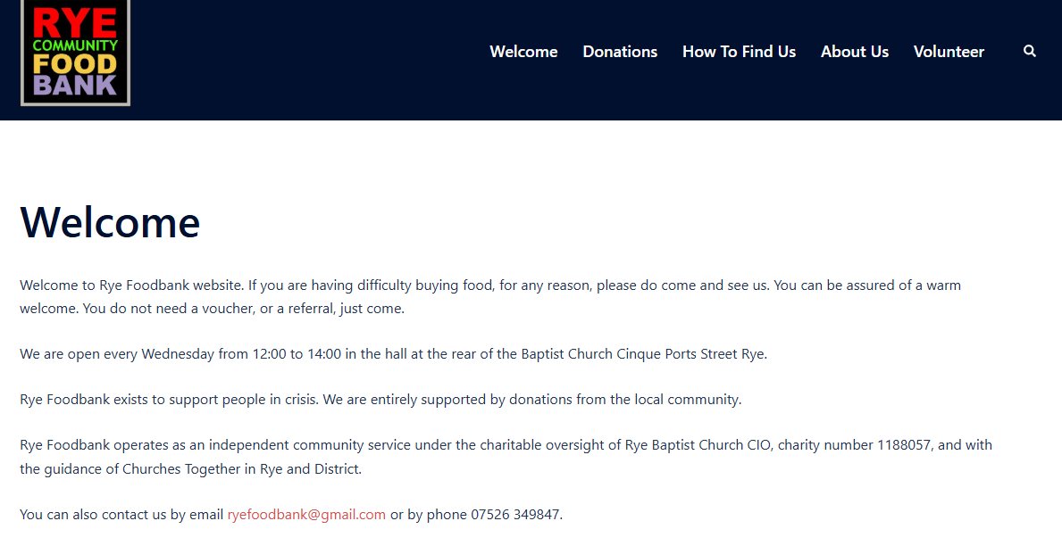

Mental Health Support:






Release the Pressure:
Text SHOUT to 85258 or call 0800 1070160
Samaritans:
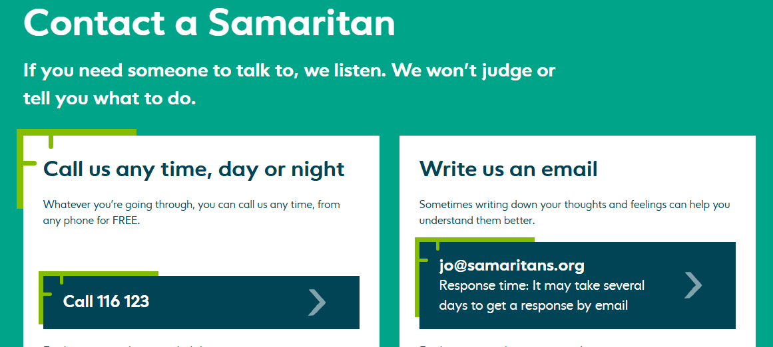
Call 116 123 or email jo@samaritans.org

Ashford Safe Haven:
Ashford Safe Haven - 07811 593 219
The Paula Carr Centre, William Harvey Hospital, Kennington Rd, Willesborough, Ashford TN24 0LZ
Open every day, including weekends and bank holidays, from 6.30pm to 11.30pm.
Out-of-hours mental health support for anyone aged 18 and over in the Kent area. If you are feeling distressed, overwhelmed, or in crisis and need someone to talk to when other services are closed, our team is here to help.
Walk-in service – no referral needed. Welcoming, safe, comfortable, and non-judgmental environment. One-to-one emotional support from trained mental health professionals.

Folkestone Safe Haven:
Folkestone Safe Haven – 07967 877096 / 07967 877097
3 Rendezvous Street, Folkestone, Kent CT20 1EY
Monday to Sunday, 6pm-11pm.
The Folkestone Safe Haven offers a welcoming, safe, comfortable, non-judgmental and non-clinical environment, sometimes known as 'crisis cafes'. At the safe haven, we will be able to provide information and emotional support if you are in crisis or feel you are heading towards a crisis situation.
Domestic Abuse Services:
National Domestic Abuse Helpline: 0808 2000 247

Kent and Medway Domestic Abuse Partnership: 0808 168 9276

Domestic Abuse Service East Sussex: 0300 323 9985

Domestic Abuse drop-in service:
Ashford: The Willow Centre, Brookfield Road, Ashford, TN23 4EY.
Tuesdays 9.30am – 12.00pm.
Folkestone: Family Hub, Dover Road, Folkestone, CT20 1QF.
Thursdays 12:30 – 2:30pm.

Children/Young People Services:
Kent Social Services:
During office hours: 03000 41 11 11
Out of hours (after 5pm / Urgent calls only) please contact: 03000 41 91 91

East Sussex Social Services:
During office hours: 01323 464222
Out of hours: 01273 335905

Early Help:
Ashford - 03000 41 03 05 - AshfordEarlyHelp@kent.gov.uk
Folkestone and Hythe - 03000 41 10 08 - ShepwayEarlyHelp@kent.gov.uk

NSPCC:

Call: 0808 800 5000 or email help@NSPCC.org.uk

ChildLine:
Call: 0800 1111 or visit www.childline.org.uk for 1:1 chat service

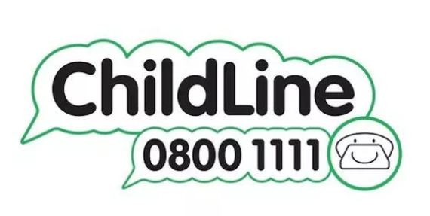

Other support:

Debt Support:
Step Change Debt Charity: Call 0800 138 1111. Monday to Friday 8am to 8pm and Saturday 9am to 2pm. Or visit www.stepchange.org

Folkestone Rainbow Centre Money First Aid:
Supporting You Out of Debt to a Better Future.
Money First Aid is a partnership of well-known local non-profit organisations helping local people who are struggling with their finances to regain control.
Visit www.rainbow-centre.org/our-services/money-matters/ to complete a self-referral form and send it to mfa@doverdealcitizensadvice.org.uk or call Citizens Advice on 01304 353861.

Substance Use support:
Alcoholics Anonymous: If you need help with a drinking problem either phone our national help line on 0800 917 7650 or contact us by email: help@aamail.org

Forward Trust: East Kent call 0300 304 8007 or email info@forwardtrust.org.uk
Supporting people to recover from addiction.

DrinkAware – www.drinkaware.co.uk
Trained advisors are on hand to support you with confidential advice about alcohol.

Folkestone and Hythe District Council (Housing/homelessness):
Housing (including council tenant, rent & repairs, housing waiting list and homelessness) - 01303 853300 or email housing@folkestone-hythe.gov.uk

Ashford Borough Council (Housing/homelessness):
If you are homeless, or think that you are about to become homeless, we can provide you with help and advice. Please contact us as soon as possible so that we can assess your situation in detail.
Call us on 01233 331111. This number is available 24 hours and 7 days a week.

East Sussex (homelessness):
www.eastsussex.gov.uk/community/housing/homelessness

Citizens Advice:
Visit www.citzensadvice.org.uk or call: 0800 144 8848



